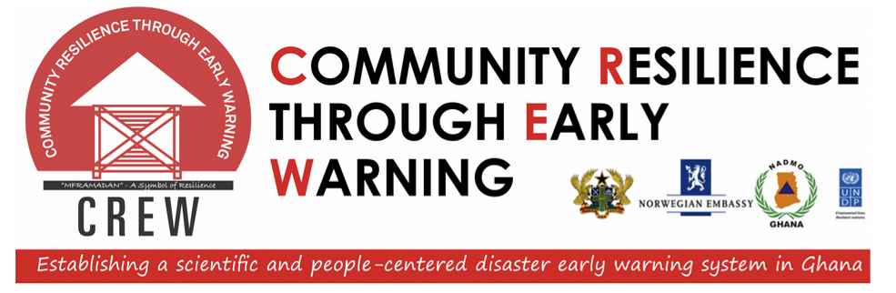
ANNUAL REPORT
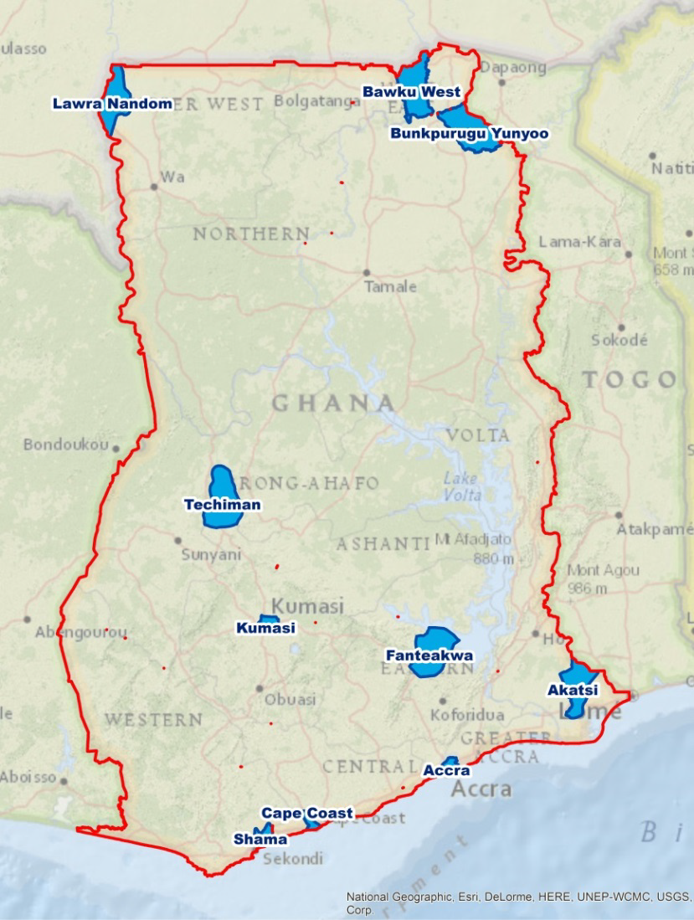
BY
CREW PROJECT MANAGEMENT UNIT
DEC, 2014
Contents
1 INTRODUCTION 4
1.1 2013 Achievements 6
2 QUARTER 1 2014 7
2.1 Objectives 7
2.2 Recruitment of Project Consultants 7
2.3 Community Entry and M & E Baseline Data Collection 7
2.4 Methodology Development for Hazard, Vulnerability and Risk Mapping and EWS 10
2.5 Q1 FINANCIALS 10
2.6 Emerging Issues and Lessons Learnt (Opportunities & Challenges) 11
2.6.1 MMDA Disaster Management Committee Meetings 11
2.6.2 Data Availability 12
2.6.3 Gender Balance 12
3 QUARTER 2, 2014 13
3.1 Objectives: 13
3.2 Project Inception Report 13
3.3 Community Entry and M & E Baseline Data Collection 13
3.4 Procurement of capacity building equipment for beneficiary agencies 14
3.5 Q2. 2014 Financials 14
3.6 Emerging Issues and Lessons Learnt (Opportunities & Challenges) 16
4 QUARTER 3, 2014 17
4.1 Objectives: 17
4.2 Second CREW Multi-Stakeholder Technical Working Group Workshop 17
4.3 Procurement of capacity building equipment for beneficiary agencies 18
4.4 Research on the causes of disaster vulnerability among households in CREW pilot districts 19
4.5 Pilot district level flood and drought risk assessment 20
4.6 National level assessment and flood/drought hazard and vulnerability map development 20
4.7 Q3, 2014 Financials 21
4.8 Emerging Issues and Lessons Learnt (Opportunities & Challenges) 22
4.8.1 Time allocation for field data collection 22
5 QUARTER 4, 2014 23
5.1 Objectives: 23
5.2 Development of national level hazard, vulnerability and risk maps for flood and drought disasters 23
5.3 Development of district level flood/drought hazard, vulnerability and risk maps; 36
5.4 Installation of WEBEOC equipment and automated weather stations 37
5.5 Study on the causes of disaster vulnerability among households in the pilot communities 37
5.6 The M&E baseline indicators verification 37
5.7 Q4, 2014 Financials 38
5.8 Emerging Issues and Lessons Learnt (Opportunities & Challenges) 39
5.8.1 Project vehicle release 39

INTRODUCTION
Development and disaster risk reduction (DRR) are inherently linked; capacities for DRR are significant factors for development as recurrent natural disasters can undermine the significant investments and improvements made through the development process. Sustainable development strengthens DRR capacities, providing governments and communities with policies, infrastructure, systems, and knowledge to build their resilience. Although strong economic growth over the past two decades in Ghana has led to a reduction in poverty and a shift to lower middle income status. However, this has occurred without a corresponding and systematic reduction of disaster risks in most communities. DRR is therefore and urgent and significant development issue in Ghana. Recognizing the importance of strengthening DRR capacities in achieving sustainable development and poverty reduction in Ghana, the United Nations Development Programme (UNDP) has worked closely with the Government of Ghana (GoG) in providing technical and financial support in this area. The Norwegian Government through the UNDP is providing both comprehensive and targeted support to GoG in delivering some of the key components from the 2013 Ghana Plan of Action for Disaster Risk Reduction (DRR) and Climate Change Adaptation (CCA) through the Community Resilience through Early Warning (CREW) Project.
The project’s strategy is to build capacities within the country to reduce disaster risk by putting in place an integrated Early Warning System that is both scientific and people centred. The project is designed in a way that aligns it with the Hyogo Framework of Action (HFA) and the Ghana Plan of Action for DRR and CCA, and leads to tangible results in both the short-term and long-term. The goal of the project is to reduce disaster risks through better understanding of risks, reducing vulnerability to hazards, and enhancing capacities for disaster risk reduction. The main objective(s) are to develop risk maps for flood and drought disasters, reduce the underlying vulnerabilities and enhance coordination and capacities for Early Warning Systems in 10 pilot sites by 2015 (see fig.1 for the location of the 10 pilot sites. The anticipated results are:
- Economic and human losses and damages from priority hazards (i.e. floods and droughts) are reduced; and
- Successful Early Warning is issued and communicated for priority hazards in 10 pilot Districts.
The CREW project document was successfully endorsed by NADMO and UNDP on November 24, 2012. This report details the activities and achievements for year 2 of the project (2014).

Figure 1: Map of CREW Pilot Districts

2013 Achievements
Project activities already carried out in 2013 included:
- the establishment of an effective Project Management structure through the recruitment of qualified professionals and essential tools/supplies;
- the completion of timely and high quality implementation of Project Inception activities;
- development of a baseline report and database on disasters in Ghana;
- Initiating the hiring of project consultants’
- establishment of Technical Working Group on floods and drought disasters;
- regional consultative workshops, and
- selection of pilot districts for project implementation.
Building on the activities undertaken in 2013, the main goals for 2014 were geared towards:
- completing the hiring of project consultants;
- Community entry and baseline data collection;
- Community flood and drought risk assessment;
- Flood hazard/vulnerability/Risk modelling and mapping at the national and pilot district level;
- Drought hazard/vulnerability/Risk modelling and mapping at the national and pilot district level;
- Second research technical working group workshop;
- A study on the causes of disaster vulnerability among households in the pilot districts,
- Initiate Flood and Drought EW gap analysis,
- Initiate development of disaster risk profiles of the 10 pilot communities, and
- Procurement and installation of capacity building equipment for stakeholder institutions.

QUARTER 1 2014
The first quarter of 2014 for the CREW project was occupied mainly with activities leading up to finalising the recruitment of project consultants, community entry and baseline data collection as well as hazard mapping methodology development in conjunction with vulnerability mapping and EWS development.

Objectives
Key objectives of the 1st quarter of 2014 for the CREW project were to:
- Finalise the hiring of the international consultant;
- Undertake community entry and M&E baseline data collection and field visits, and
- Initiate hazard mapping methodology development in conjunction with vulnerability mapping and EWS development.

Recruitment of Project Consultants
The hiring of the international consultant for the project (Royal Haskoning DHV) was finalised on 15th January 2014 following the successful negotiations of the contract terms thus clearing the way to realising key project objectives of flood and drought risk mapping and EWS development. Upon signing the contract, the project consultant submitted a final approach and strategy document on 4th February, 2014 detailing their road map for executing the activities under the contract and the methodological processes to be followed in that quest. The consultant also received an initial payment of 20% of their fees upon submission of the final strategy and approach document for the project. Preparations and submission of a formal project inception report by the consultants was also initiated during this period for submission in the subsequent quarter.

Community Entry and M & E Baseline Data Collection
The project management team comprising the Project Manager, Technical Advisor, National Technical Specialist and Monitoring and Evaluation Officer embarked on a community entry activity involving M&E baseline data collection and visits to flood and drought prone communities within the CREW pilot districts namely: Accra, Cape Coast and Kumasi Metropolitan Areas; Shama and Techiman Municipal Areas; Akatsi South, Fanteakwa, Lawra, Bawku West and Bunprugu Yunyoo Districts. This mission served as entry into selected MMDs to introduce the project to district authorities and key stakeholders who would be actively engaged throughout the project implementation. The mission was also aimed at collecting reliable data on selected pilot MMDs which would help set project baseline data for each of the districts. This would help the project to measure and evaluate the impact of the project on selected districts and at the national level. The baseline data would also be useful for monitoring and evaluation activities of the project.
The mission was additionally used to compile comprehensive district profiles and identify district specific needs and local contexts that need to be factored into vulnerability and risk assessments. These profiles would assist the project to ensure that methods and tools developed are implemented adequately to reflect the local context of each district. Besides, it is expected that through the engagement with the districts, the project would adequately respond to community perceptions, cultural and social needs of the selected pilot districts. The team also visited some disaster prone communities within the pilot districts to gain an understanding of the nature of the damages caused by the disasters, preparedness and response mechanisms that have been used during past disasters which would eventually aid in the implementation of appropriate vulnerability reduction interventions in the selected communities.
The mission was undertaken in two (2) phases in the period between 11th March and 9th May 2014. Phase I (southern sector) involved visits to the Akatsi, Shama, Cape Coast and Fanteakwa from the 11th – 21st March 2014. The first phase, offered useful insight, experience and lessons with regards to approach, methodology and logistics needs, which helped to make the Phase II (northern sector) even more effective. The outcomes of these visits are detailed below.
High level commitment at the Regional and District levels in CREW Pilot sites obtained: The team led by the Project Manager in most of the regions and MMD called on the Regional Ministers and Chief Executives, with some Directors, Presiding Members and the NADMO Coordinators to seek their support and commitment to the CREW project. After introducing the project and strategies and systems to be employed and the expected results, the level of enthusiasm and interest for the CREW project at each of the regions and districts was high. As a result, they have committed their support to ensure that the project achieve its desired results. Where the Ministers and the Chief Executives were not available, solidarity messages were conveyed to the CREW Team through the Regional and MMDA NADMO Coordinators.
District Level engagement with key stakeholders ensured: in a workshop format, the CREW team met in each MMD, members of the Disaster Management Committee (DMCs) including the NADMO Zonal Coordinators and staff, Assembly Men/Women, MMD Planning Officers and other staff. During these meetings, the project objectives, approaches and strategies were presented and discussed with the participants. The roles and responsibilities of each stakeholder in ensuring that the project objective of reducing the impacts of flood and drought through Early Warning (EW) and Disaster Risk Reduction (DRR) measures are achieved were also discussed.
Baseline Data for setting up the CREW Project M&E framework and Plan collected: To obtain a comprehensive picture of the project areas in relation to EW and DRR knowledge, behaviours and practices, there was a data collection session during the workshop. Using a semi-structured data collection tool, developed out of the project results indicators, data was collected from participants and appropriate officers to serve as baseline against which project performance and achievements would be measured. A focus group discussion methodology was employed to obtain the data which was triangulated with other sources for validation.
The visits to disaster prone communities within the pilot MMDAs afforded the team the opportunity to witness first-hand the nature of disasters and their impact on the inhabitants. It also helped to shape our understanding of their vulnerabilities as well as provide insights into the appropriate disaster reduction measures.

Methodology Development for Hazard, Vulnerability and Risk Mapping and EWS
The development of the methodology for hazard, vulnerability and risk mapping as well as the development of the EWS was initiated by the consultants towards the latter part of the quarter. The late start of the consultancy led to the consultant’s the inability to complete this activity within the first quarter and was therefore rolled over to the second quarter.

Q1 Financials
The project’s financial standing and delivery at the end of quarter one are detailed in Tables 1 and 2 respectively.

Table 1: Quarter 1 Budget and Expenditure Summary
 | BUDGET | ACTUAL | VARIANCE
Total Outcome 1 Budget (ATLAS Activity 1) | 370,034.67 | 321,185.20 | 48,849.47
Total Outcome 2 Budget (ATLAS Activity 1) | 11,166.67 | - | 11, 166.67
Total Outcome 3 Budget (ATLAS Activity 1) | 3,166.67 | - | 3,166.67
Total Outcome 4 Budget (ATLAS Activity 4) | 34,622.00 | 65,168.91 | (30,546.91)
Total Project Inception Budget (ATLAS Activity 5) | 60,000.00 | 25,344.70 | (9,459.70)
Total | 478,990.01 | 411,698.81 | 67,291.20

Table 2: Projected Delivery by End of Q1 2014
ITEM | AMOUNT
A. Total Project Budget (2013 – 2015) | 5,162,667
B. 2014 Project Budget  (January – December 2014/Revised Budget) | 1,834,471
C. Total Budget for 2014 Q1 | 478,990.01
D. Previous Spending in 2013 | 292,481.88
E. Spending in Q1 2014 | 411,698.81
F. Spending by end of Q1 2014 (D+E) | 704,180.69
G. Delivery ( Total 2014 Budget) (E/C*100) | 85.95%
H. Delivery (Total Project Budget 2013 – 2015) (F/A*100) | 13.63%
*Note: 7% General Management Service (GMS) will be added to the actual expenditure at the end of every quarter.

Emerging Issues and Lessons Learnt (Opportunities & Challenges)

MMDA Disaster Management Committee Meetings
The MMDA Disaster Management Committee which is mandated by law, with the Chief Executive as the Chairperson and the NADMO as the coordinating body, is not functioning as expected due to financial constraints. Their meetings are mostly reactive to disaster occurrences and the committees are not able to fulfil their mandated quarterly meetings. It is therefore recommended that the committees should be supported through this project to function properly by offering capacity building programmes on DRR and EWS development and management.
The general orientation about disaster management in the MMDs has been all about providing relief to disaster victims instead of Disaster Prevention through early warnings. The CREW project could facilitate the speedy passage of the NADMO new bill. The proposed change of NADMO into National Disaster Management Service as indicated in the National Disaster Management Service Bill provides mandate to NADMO in terms of risk reduction, mitigation, preparedness, Response and Recovery. Besides, there is the need to equip and strengthen the capacity of NADMO, GMET at the National and sub-national levels in disaster preparedness and prevention.

Data Availability
Disaster data availability is a major challenge due to the absence of structures and the lack of coordination within the DMCs for collecting and storing data. Data can only be obtained at the incident level from reports which are usually sent to NADMO Headquarters. This however, offers the CREW Project an opportunity to make a difference by ensuring the establishment of a database and its management especially in the selected MMDAs and at the NADMO headquarters.

Gender Balance
There is low representation of women at the District disaster management committees in all the pilot districts visited. Given that women and children are mostly those who are badly affected when disaster occurs, the project should ensure that measures that would be put in place in reducing the vulnerabilities of the districts to disasters are gender targeted.

QUARTER 2, 2014
The second quarter of 2014 was occupied with completing the community entry and baseline data collection activity, national competitive tendering for the procurement of EW equipment for stakeholder agencies on flood and drought risk management as well as the organisation of the research technical work group workshop to finalise the methodology and approach for the study on the causes of disaster vulnerability among households in the pilot communities.

Objectives:
- Completion of consultancy inception report;
- Completion of community entry and M&E baseline data collection and field visits;
- Procurement of capacity building equipment for beneficiary agencies under the CREW project;

Consultancy Inception Report
The project consultancy inception report was submitted by the consultants in draft version on 25 April 2014. Upon receipt of the project team’s comments the final version of the inception report was submitted and accepted on 6 June 2014.

Community Entry and M & E Baseline Data Collection
As previously elaborated under quarter one, this mission was undertaken in two (2) phases in the period between 11th March and 9th May 2014 and served as entry into selected MMDs to introduce the project to district authorities and key stakeholders. It was also to enable the team to collect reliable data on selected pilot MMDs which would help set project baseline data for each of the districts and also develop comprehensive district profiles. Phase II (northern sector) this activity was undertaken in the second quarter from 27th April - 9th May 2014 and involved visits to Kumasi and Accra metropolis, Techiman municipal Area, Lawra, Bawku West and Bunkpurugu-Yunyoo pilot districts.

Procurement of capacity building equipment for beneficiary agencies
Outcome 2 of the CREW Project focuses on the enhancement of capacity for Early Warning System (EWS) for priority hazards in the country. The project document identified installation of EWS hardware in pilot sites as an important activity in this regard as well as a functioning EWS communication system for the management of disasters. This calls for the installation of the requisite hardware, software and a suitable system for facilitating EW communication within NADMO’s organisation nationwide and between NADMO and its stakeholder institutions and the general public.
The project has therefore financed the procurement and installation of 7 Automated Weather Stations (AWS) to enhance the Ghana Meteorological Authority’s (GMet) capacity for climate data collection and more reliable and accurate weather forecasting. The project is also financing the procurement and installation of river gauges equipped with audible sensor alarms in selected districts for the Hydrological Services Department (HSD). The Ghana Meteorological Authority (GMet) has been solely responsible for the procurement of AWS for this activity as is also the case with HSD in relation to the river sensors.
NADMO requested for support in the establishment of a Web-based Emergency Operations Centre (WEBEOC) from CREW Project Resources which was subsequently approved by the Project Executive Board (PEB). The project management unit together with the NADMO procurement office issued a national competitive tender for the supply of various IT equipment required for the EOC setup with five (5) companies being eventually awarded contracts for the supply and installation of equipment in the designated offices at NADMO headquarters in Accra, the 10 Regional Offices and 10 beneficiary CREW Pilot districts.

Q2. 2014 Financials
The project’s financial standing and delivery at the end of quarter 2 are detailed in Tables 3 and 4 respectively.
Table 3: Quarter 2 Budget and Expenditure Summary
 | BUDGET | ACTUAL | VARIANCE
Total Outcome 1 Budget (ATLAS Activity 1) | 91,468.02 | 0.00 | 91,468.02
Total Outcome 2 Budget (ATLAS Activity 1) | 468,707.67 | 13,584.40 | 455,123.27
Total Outcome 3 Budget (ATLAS Activity 1) | 58,166.67 | 0.00 | 58,166.67
Total Outcome 4 Budget (ATLAS Activity 4) | 34,622.00 | 29,694.02 | 4,927.98
Total Project Inception Budget (ATLAS Activity 5) | - | - | -
Total | 652,964.36 | 43,278.42 | 609,685.94

Table 4: Projected Delivery by End of Q2 2014
ITEM | AMOUNT
- Total Project Budget (2013 – 2015) | 5,162,667
- 2014 Project Budget  (January – December 2014/Revised Budget | 1,834,471
- Total Budget for 2014 Q2 | 652,964.36
- Previous Spending in 2013+Q1 2014 | 704,180.69
- Spending in Q2 2014 | 43,278.42
- Spending by end of Q1 2014 (D+E) | 747,459.11
- Delivery ( Total 2014 Budget) (E/C*100) | 6.63%
- Delivery (Total Project Budget 2013 – 2015) (F/A*100) | 14.48%
*Note: 7% General Management Service (GMS) will be added to the actual expenditure at the end of every quarter.

QUARTER 3, 2014
The third quarter of 2014 was occupied with finalising the procurement of capacity building equipment for stakeholder institutions, holding the second research technical work group meeting as well as undertaking the research study on the causes of disaster vulnerability among households in the CREW pilot communities. The development of national level hazard, vulnerability and risk maps for floods and drought was also initiated within the quarter.

Objectives:
The key activities scheduled for Quarter 3 in 2014 were to:
- Conduct the Research Technical Working Group (RTWG) workshop to finalise the methodology and questionnaire for the study on Social behavioural analysis on the causes of disaster vulnerability the 10 pilot districts;
- Complete the procurement of capacity building equipment for beneficiary agencies under the CREW project, continued from Q2;
- Initiate study on the causes of disaster vulnerability in pilot districts;
- Undertake CREW pilot district level flood and drought risk assessment;
- Initiate national level hazard, vulnerability flood/drought risk assessment and map development; and

Second CREW Multi-Stakeholder Technical Working Group Workshop
The second multi-stakeholder Technical Working Group (TWG) was held on 23rd-25th July 2014 at the Sky Plus Hotel in Ho.
The objectives of the second workshop were to:
- Update TWG members on CREW project activities within the past year
- Discuss and finalize the approach and methodology for the study on social behavioural analysis of the causes of disasters and vulnerability typology analysis for the 10 pilot districts, and
- Review of household questionnaire on the study of the causes of disaster vulnerability in CREW pilot sites.

CREW RTWG members were updated on all project activities for the first year and developments since the initial meeting in 2013. Members had the opportunity to contribute to the methodology and approach for the study on the causes of disaster vulnerability in the pilot districts. The RTWG members also helped in the review and finalization of the questionnaire for the household survey for the study. The PMU had prior to the workshop shared a draft household survey questionnaire on the study with members of the RTWG in order to provide them with enough time to assess the survey instrument and make their input during the workshop. The RTWG members brought their varied expertise to bear in finalising the questionnaire for the study during the workshop.

Procurement of capacity building equipment for beneficiary agencies
Upon the completion of the national competitive tendering process, contracts were awarded to 5 companies for the supply and installation of WEBEOC equipment for NADMO. Details of the equipment procured are presented in table 5. Automated weather stations (AWS) were also procured for Gmet using their own procurement processes and the equipment arrived at the end of December 2014 for on-site installation in early 2015 following completion of on-going site preparatory works. The tender for the river gauges for the Hydrological Services Department was cancelled because the bids submitted were beyond the scope of the project budgets.

Table 5: WEBEOC Equipment Procured
PROJECT LOT | ITEM/QTY | DESCRIPTION
Lot 3 - Led Screens | (25) LED TVs | 45-50" LED High Full HD TV, 1080p, 3x HDMI, USB ports
Lot 4 - Biometric Attendance | (25) Biometric attendance | Employee biometric fingerprint attendance time clock/PC management Suite, TCP IP capable
Lot - 5 VoIP Telephony | (25) VOIP Phone | Business grade SIP Handset, PoE,
Lot - 5 VoIP Telephony | (1) PBX | IP PBX, up to 5,000 extensions, rack mountable
Lot 6 - Video Surveillance | (50) Surveillance cameras | 2MP Vandal proof Day/night (infra-red) IP dome camera (PTZ)
Lot 6 - Video Surveillance | Network switches | Ethernet switch
Lot 6 - Video Surveillance | (2) Network Video Recorder | 32-Channel NVR (for HQ) - X2
Lot 6 - Video Surveillance | Management Software | Integrated Software
Lot 6 - Video Surveillance | Hard disks | 8TB Hard disks
Lot 6 - Video Surveillance | (1) Monitoring | Monitoring console (KVM, keyboard/PTZ functions/50" LED @ HQ
lot 7 - video conferencing/ recording | (25) Video Conference kit | Multi-point Video conferencing kit/software/licenses
lot 7 - video conferencing/ recording | (25)Video Cameras | Full HD (1080p) 16.7MP Camcorder, 10x optical zoom, image stabilizing, USB, HDMI

Research on the causes of disaster vulnerability among households in CREW pilot districts
Following the research technical work group workshop held in Ho to finalise the approach and methodology as well as household questionnaire to be employed in data collection, the research study on causes of disaster and vulnerability in pilot communities was commenced. The objectives of this study were to investigate the causes of floods and drought disaster vulnerabilities in the 10 CREW Project Pilot districts and to examine the range of DRR measures required to reduce the vulnerabilities within the households and communities in these districts. The study also sought to examine the household perceptions, response, coping and adaptation strategies to flood and drought disasters and climate change in general. A team made up of the project technical advisor and project officer embarked on household data collection in the project pilot districts. Data collection was split into phase 1 (northern sector) and phase 2 (southern sector) and was undertaken from July to September 2014. Questionnaires were administered with the help of field assistants indigenous to the community in each of the pilot districts with guidance and supervision from the team. Focus group discussions, personal interviews and observations were other sources of data used in the study. The completed questionnaires for each district were collated and subsequently transported to the project office for the entry and analysis.

Pilot district level flood and drought risk assessment
The project consultants were engaged in district/community flood and drought risk assessment in pilot sites during this quarter. Following the desktop analysis and composition of the risk maps there was the need for field visits which focused on the verification of hazard maps so developed to enable them validate their outputs prior to the finalization of the district specific hazard, risk and vulnerability maps particularly in the case of floods. Members from the project management unit were on hand to facilitate community meetings and site visits with the consultants to ensure greater awareness and ease of entry for them. The risk assessment and verification of the maps activity was divided into 3 phases over a period of 3 months for the northern, middle and southern sectors of the country and provided important input into the development of the final hazard, vulnerability and risk maps.

National level flood/drought hazard, vulnerability and risk assessment and map development
The national level flood and drought hazard, vulnerability and risk assessments were undertaken by the consultants with inputs from the project team during this quarter. This led to the identification of the different risk zones and levels associated with floods and drought on a national scale. The results of these assessments led to the development of spatial map products on hazards, vulnerabilities and risks to both floods and drought using two climate scenarios; the current (2010) and future (2050) based on the IPCC criteria and Regional Climate Model. The methodology for carrying out these assessments are detailed in Report 1 by the consultants which covered the literature and data employed, historical hazards and Methodology for hazard vulnerability and risk mapping at the national level submitted in June 2014. A final version of the report which incorporated comments from the project team was submitted in September 2014. It should be noted that the methodology employed in the various map outputs had been the subject of some previous meetings held with the consultants during which the project team had sought understanding and made input into the final methodology.

Q3, 2014 Financials
The project’s financial standing and delivery at the end of quarter three are detailed in Tables 6 and 7 respectively.
Table 6: Quarter 3 Budget and Expenditure Summary
ITEM | BUDGET |  | ACTUAL | VARIANCE
Total Outcome 1 Budget | 38,596.67 |  | 6,532.18 | 14,755.50
Total Outcome 2 Budget | 215,233.34 |  | - | 210,762.96
Total Outcome 3 Budget | 6,670.00 |  | - | 4,434.81
Total Outcome 4 Budget | 29,624,11 |  | 35,145.26 | 8,159.58
Total Project Inception Budget | 50,000.00 |  | 35,233.31 | 5,183.82
TOTAL | 340,124.12 |  | 76,910.75 | 251,242.11

Table 7: Projected Delivery by end of Q3 2014
ITEM | AMOUNT
- Total Project Budget (2013 – 2015) | 5,162,667
- 2014 Project Budget: (Revised Budget) | 1,834,471
- Total Budget for 2014 Q3 | 529,070.39
- Previous Spending in 2013+Q1+Q2 | 747,459.11
- Spending in Q3 2014 | 288,710.96
- Spending by end of Q3 2014 (D+E) | 1,036,170.07
- Delivery ( Total 2014 Budget) (E/C*100) | 54.57%
- Delivery (Total Project Budget 2013 – 2015) (F/A*100) | 20.07%
*Note: 7% General Management Service (GMS) will be added to the actual expenditure at the end of every quarter.

Emerging Issues and Lessons Learnt (Opportunities & Challenges)

Time allocation for field data collection
The period approved for data collection for the study on the causes of disaster vulnerability among households in the pilot districts proved very inadequate to ensuring the data quality was guaranteed. Data entry revealed that the questionnaire were not very well completed in several instances though the tight time schedules for data collection ensured that it was virtually impossible to validate and clean the completed questionnaire for subsequent corrections and or re-administration by the respective field assistants.

QUARTER 4, 2014
The fourth quarter of 2014 was occupied with the completion of all outstanding project activities planned for the year. These were mainly related to the completion of the national level hazard, vulnerability and risk maps for drought and flood disasters and the installation of the procured capacity building equipment for the beneficiary agencies. It also included the completion of data entry and analysis for the study on the causes of disaster vulnerability in the project pilot districts as well as the verification of M&E baseline indicators for the project.

Objectives:
The key activities scheduled for Quarter 4 in 2014 were to:
- Complete national level hazard, vulnerability and risk assessment for flood and drought disasters;
- Development of district level flood/drought hazard, vulnerability and risk maps;
- installation of capacity building equipment for beneficiary agencies under the CREW project;
- Conduct data entry and analysis on the causes of disaster vulnerability CREW in pilot districts; and
- Conduct M&E Baseline indicators verification exercise.
- Project audit.

Development of national level hazard, vulnerability and risk maps for flood and drought disasters
National level maps for hazard vulnerability and risk for floods and droughts which address the current scenario as well as a future scenario (2050) were submitted by the consultants in October 2014. Comments from the project team were provided to the consultants and the final version of these deliverables was submitted on 5 December 2014. Twenty-five copies of each of the hazard, vulnerability and risk maps for both floods and drought were delivered by the consultants to the project management unit in hard copy A0 size print outs in addition to soft copy versions. Samples of these maps are provided in figures 2-13 below.

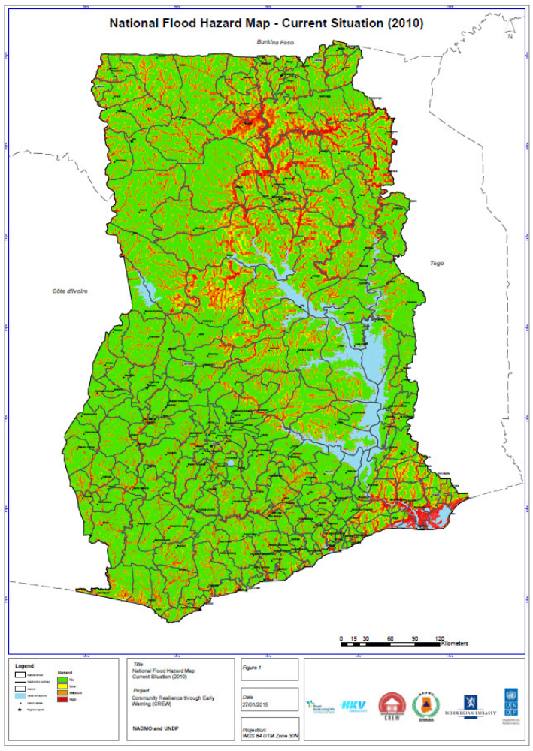
Figure 2: National flood hazard map - current situation (2010)
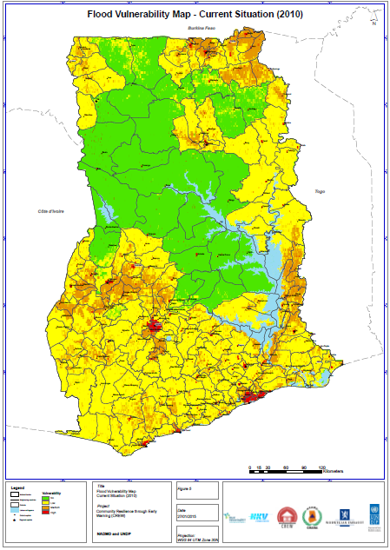
Figure 3: National level flood vulnerability map - current situation (2010)
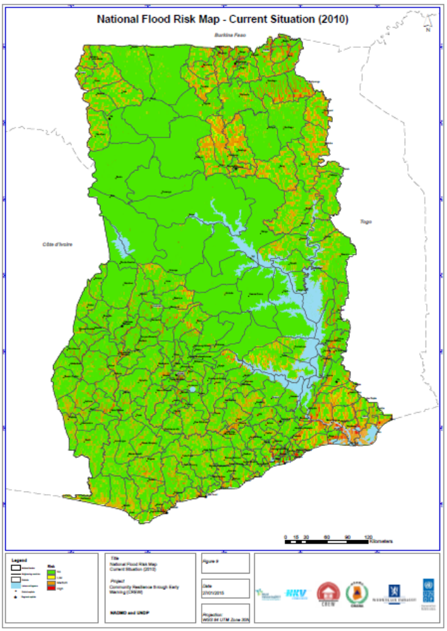
Figure 4: National level flood risk map – current situation (2010)
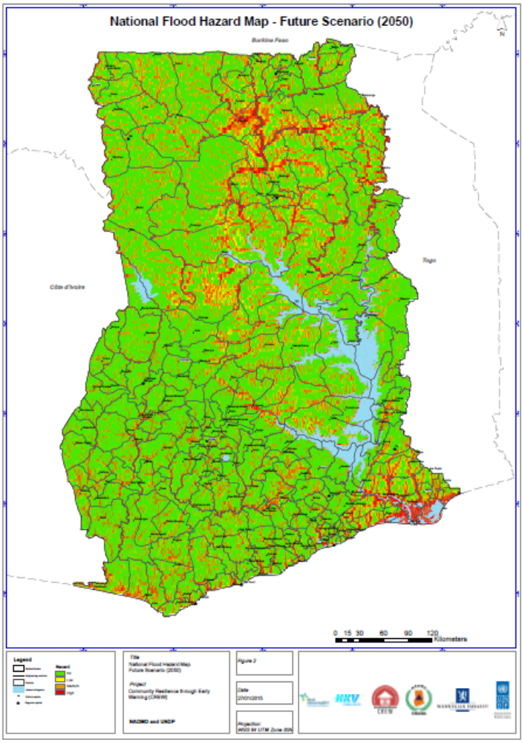
Figure 5: National level flood hazard maps - future scenario (2050)

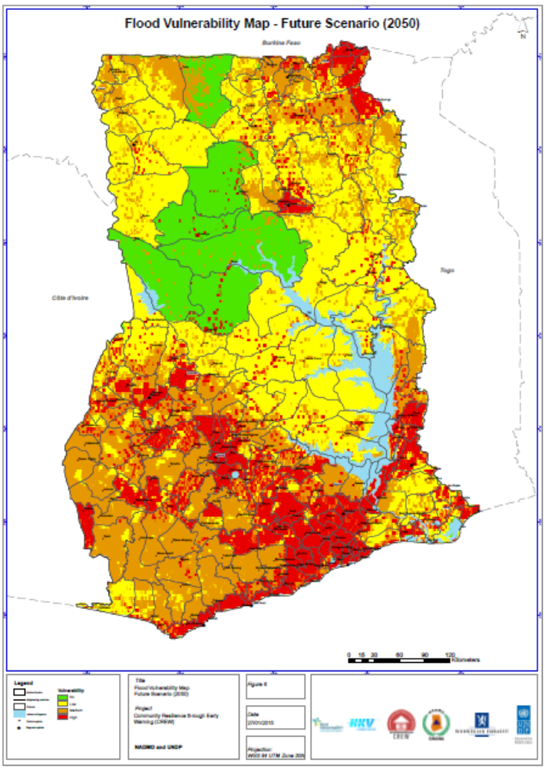
Figure 6: National level flood vulnerability map – future scenario (2050)

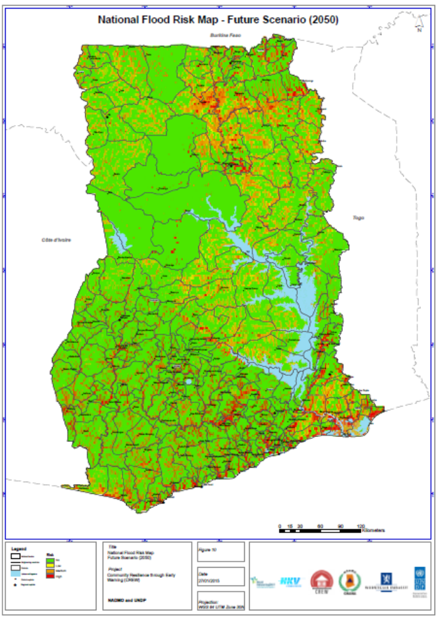
Figure 7: National level flood risk map – future scenario (2050)

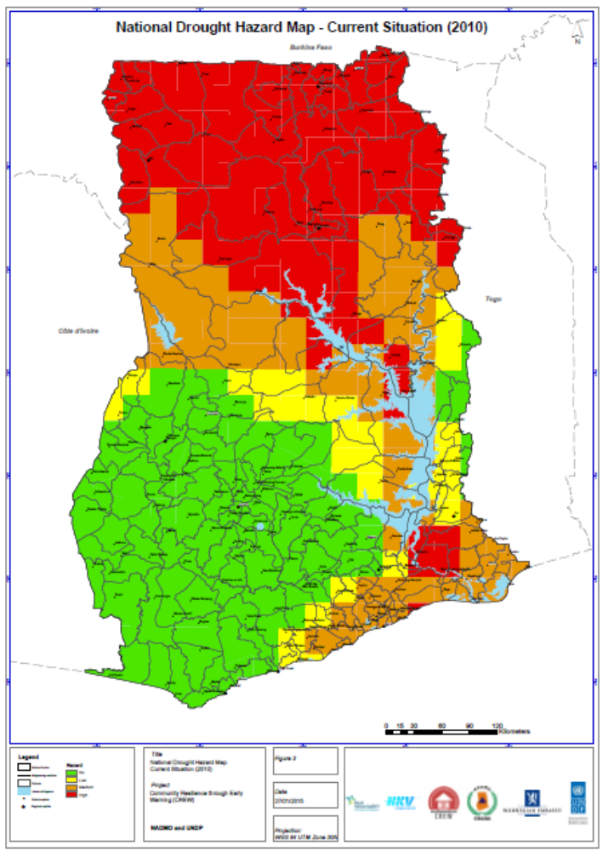
Figure 8: National level flood hazard map – current situation (2010)
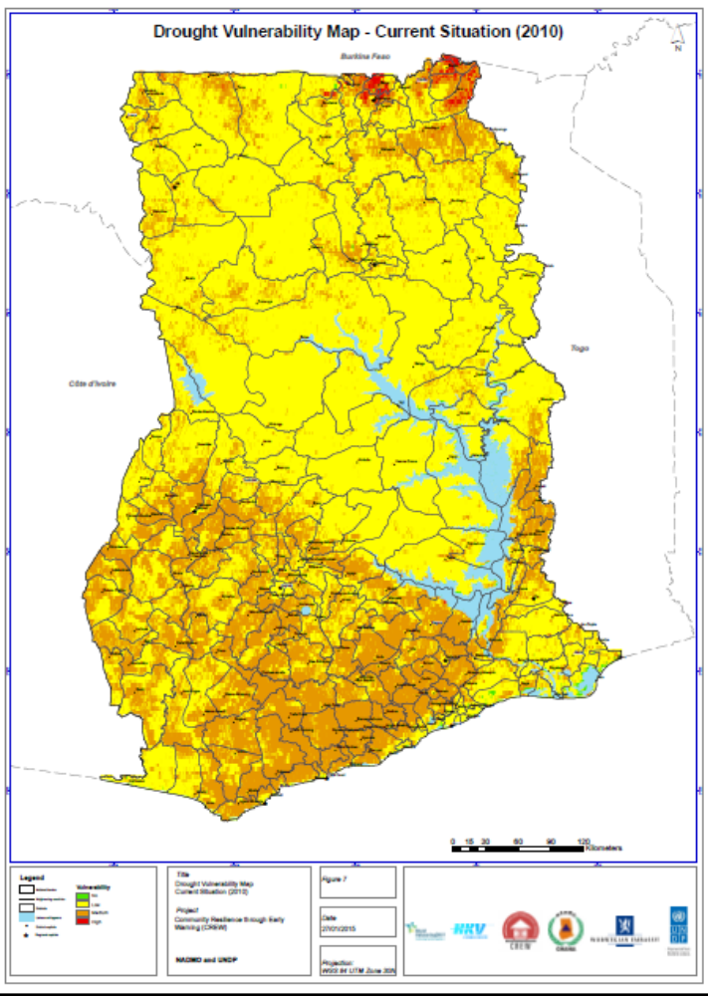
Figure 9: National level drought vulnerability map – current situation (2010)
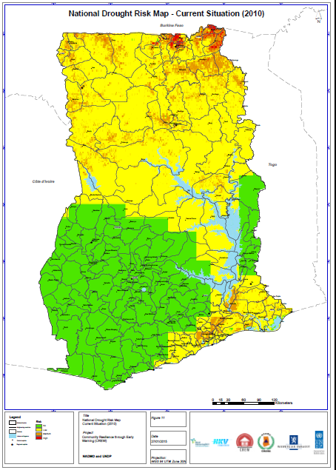
Figure 10: National drought risk map – current situation (2010)

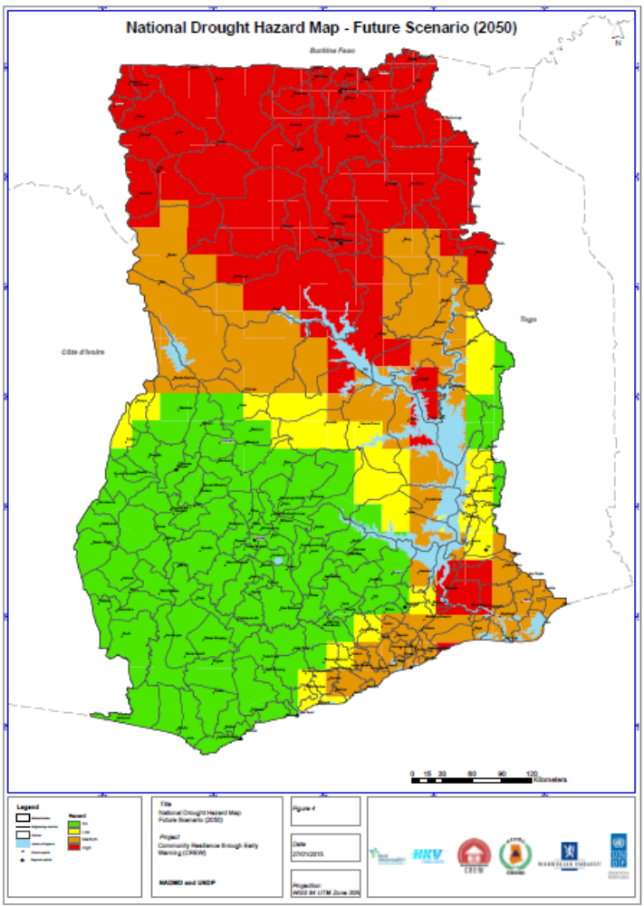
Figure 11: National level drought hazard map – future scenario (2050)
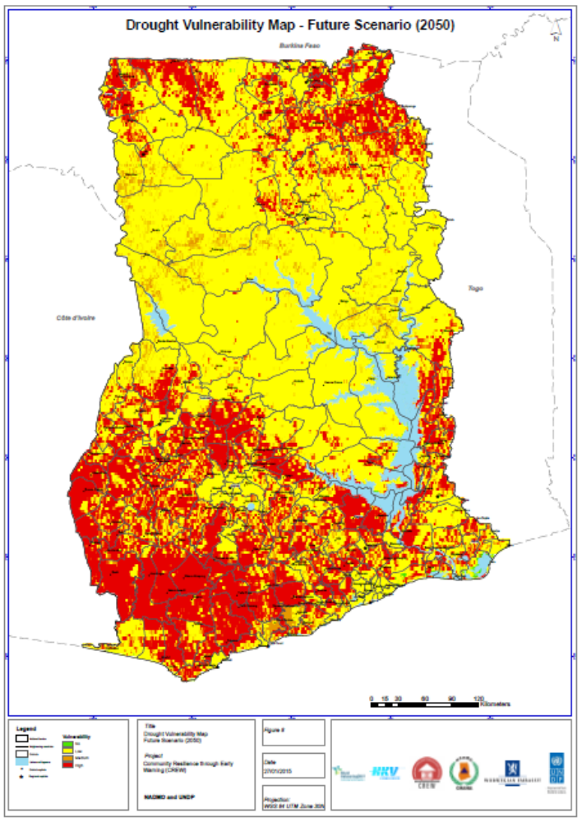
Figure 12: National level drought vulnerability map – future scenario (2050)

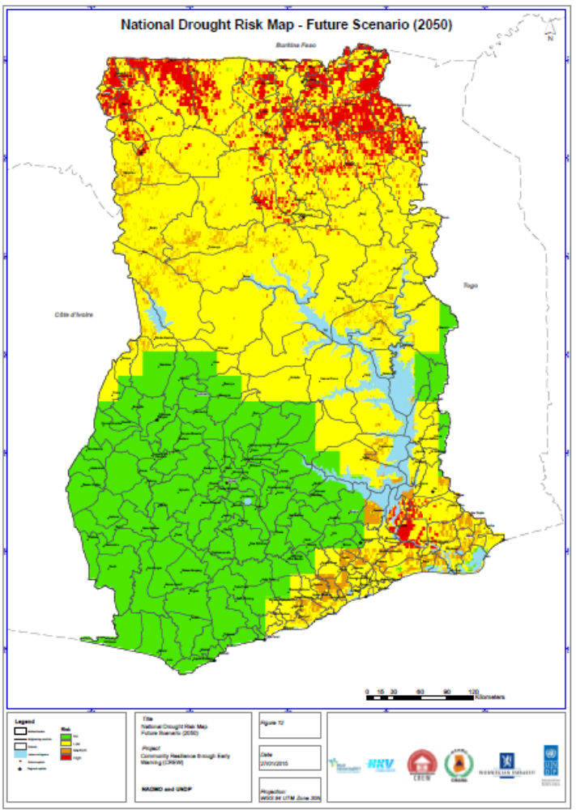
Figure 13: National level drought risk map – future scenario (2050)

Development of district level flood/drought hazard, vulnerability and risk maps
The hazard, vulnerability and risk maps for the 10 pilot sites were submitted in December 2014. Relative to the national level maps, the district maps are large scale maps requiring better resolution data for assessment and analysis of the flood and drought disasters. A higher resolution digital terrain model (DTM) of the pilot districts was therefore procured by the project to aid in the district level mapping. Sample district level hazard, vulnerability and risk maps for floods and droughts are presented in figure 14. The associated community-based vulnerability and capacity assessment report for all 10 pilot sites and Risk profiles of the 10 disaster hotspots is due in the first quarter of 2015.
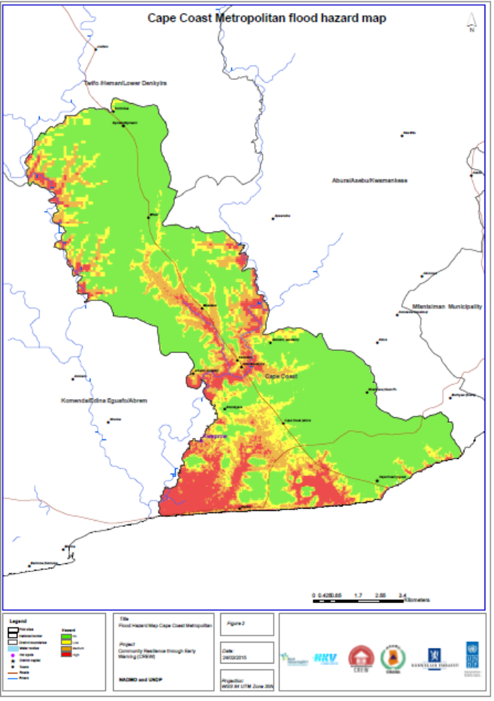
Figure 14: Cape Coast flood hazard map

Installation of WEBEOC equipment and automated weather stations
The Procurement of capacity building equipment for the beneficiary agencies has been completed. Items procured have been supplied and installations have started at the NADMO headquarters and other offices in Accra, the regions and beneficiary MMDAs. Installations of all procured equipment are scheduled to be completed by the end of the first quarter of 2015. The installation of AWS equipment has been preceded by site selection and preparatory works by GMet following the notice of shipment of the AWS equipment by the supplier. Installations are expected to be completed for commissioning by the second quarter of 2015.

Study on the causes of disaster vulnerability among households in the pilot communities
Following the completion of data collection on the study, a short-term appointment was made for data entry of questionnaire responses into the SPSS statistical software package for subsequent analysis and reporting. The objective of this consultancy assignment was to develop a digital dataset of the questionnaire responses from the households in the CREW pilot districts in the SPSS format for subsequent analysis by the research team. The results of this assignment will contribute to the understanding the causes of floods and drought disaster vulnerabilities in the 10 CREW Project Pilot districts and to examine the range of DRR measures required to reduce the vulnerabilities within the households and communities in these districts. The results would also help to understand the household perceptions, responses, coping and adaptation strategies to flood and drought disasters and climate change in general. Data entry was undertaken and completed from 1st - 30th September 2014. Data analysis and report writing has been on-going since with the draft report for the study expected by the end of Q1 2015.

The M&E baseline indicators verification
This was a follow up to the earlier mission on community entry and baseline data collection which did not offer the window to address discrepancies. The objective of the mission was therefore to collect data for priority disasters using a standard format that address the gaps in the previous mission as well as establish data collection modalities with MMDA’s DMCs. The mission also served to address discrepancies and quality assure data obtained from the previous mission on selected pilot MMDAs which would help update and finalize project baseline information.
Data was collected in a participatory manner with the aid of an instrument that had been developed and tested. This ensured both data harmonisation as well as the possibility to disaggregate data to address the key targets and results areas contained in the AWP. Addressing the data inconsistencies using the standardised format also enabled consistency in data aggregation and comparability. The activity was undertaken from 30 November – 16 December, 2014 by a two man team comprising the project M&E officer and the UNDP M&E analyst of the sustainable development cluster of the UNDP.

Project Audit
The project was the subject of a performance audit by the Office of Audit and Investigation (OAI) UNDP, HQ. The OAI developed a new approach on conducting performance audits for UNDP projects across the world. The objective of this approach is to determine to what extent projects are managed in an effective and efficient manner aimed at achieving project results. OAI used the CREW Project to test the effectiveness of this new approach. The audit findings are expected in Q1, 2015.

Q4, 2014 Financials
The project’s financial standing and delivery at the end of quarter four are detailed in Tables 8 and 9 respectively.

Table 8: Quarter 4 Budget and Expenditure Summary
 | BUDGET U$D | ACTUAL U$D | VARIANCE U$D
Total Outcome 1 Budget (ATLAS Activity 1) | 240,889.05 | 253,337.92 | (12,448.87)
Total Outcome 2 Budget (ATLAS Activity 2) | 367,571.59 | 371,925.26 | (4,354.17)
Total Outcome 3 Budget (ATLAS Activity 3) | 188,866.42 | 169,539.21 | 19,327.21
Total Outcome 4 Budget (ATLAS Activity 4) | 34,622.00 | 47,033.59 | (12,411.59)
Total Project Implementation (ATLAS Activity 5) | 0.00 | 7,030.05 | (7,030.05)
Total | 885,112.06 | 848,866.03 | 36,246.03

Table 9: Projected Delivery by End of Q4 2013
ITEM | AMOUNT
- Total Project Budget (2013 – 2015) | 5,162,667.00
- 2014 Project Budget: (Revised Budget) | 1,834,471.00
- Total Budget for 2014 Q4 | 885,112.06
- Previous Spending in 2013+Q1+Q2+Q3 2014 | 1,036,170.07
- Spending in Q4 2014 | 848,866.03
- Spending by end of Q4 2014 (D+E) | 1,885,036.10
- Delivery ( Total 2014 Budget) (E/C*100) | 95.90%
- Delivery (Total Project Budget 2013 – 2015) (F/A*100) | 36.51%
*Note: 7% General Management Service (GMS) will be added to the actual expenditure at the end of every quarter.

Emerging Issues and Lessons Learnt (Opportunities & Challenges)

Project vehicle release
Following the hiring of a temporary driver for the project, The Toyota Land Cruiser Prado (Plate no. GS1474-13) representing assistance of the UNDP to aid in the implementation of activities of the project was released to the project management unit. NADMO management which had earlier provided the project management unit with a temporary vehicle, Mitsubishi Pajero (Plate no. GS7943-12) however directed the project management unit to continue the usage of the temporary vehicle and had the project vehicle re-assigned to the Deputy National Coordinator who had been given overall responsibility for the project. This proved a challenge as the project driver was not authorized to drive the NADMO vehicle rendering him virtually idle from the period of this directive.

Summary Achievements
Through the Funds provided by Government of Norway, The CREW Project has being engaging stakeholders at sub-national, national and international levels, aimed at ensuring that a broader spectrum of stakeholders are involved to achieve tangible results of the project. In addition to building capacities and raising the level of knowledge on disaster risks at the National and subnational levels, the CREW Project is working closely with ten (10) pilot districts to implement appropriate disasters risk reduction measures and the development of an effective early warning system at the national and subnational levels; a test case of translating policies into local actions. The project as at 31st December 2014 has been able to expend about 36% of its allocated resources. Key achievements of the CREW project include:

- A comprehensive assessment of floods and droughts hazards, vulnerability and risks has been conducted at the national level for Ghana. A training Programme is being done to train both national and subnational level officers on how to conduct multi-hazards risk assessment.

- Methodology for floods and drought risks assessment have been developed
- National level floods and droughts hazards, vulnerability and risk maps at current (2010) and future scenarios (2050) have been developed. This is aimed at achieving outcome 1 and 2 of the CREW project.
- Floods and droughts hazards, vulnerability and risk assessment have been conducted at five rural districts and five urban districts of Ghana.
- 10 District level maps for floods and droughts hazards, vulnerability and risks maps have developed.
- Disaster Risk profiles for the 10 pilot sites of the project are being developed.
- Through the establishment of the participatory multi-stakeholder research teaching working groups, a number of capacity building workshops at National levels (one national level workshop) 10 regional level workshops and 10 district level workshops were conducted to increase the level of knowledge on hazards risks and vulnerability reductions measures.
- The identification and assessment of the existing status, challenges, and opportunities for EWS in Ghana are being undertaken at both the national and subnational levels. This is aimed at achieving outcome 2 of the CREW project.
- Early Warning communication equipment have been procured and installation is on-going at the national and subnational levels.
- Seven Automated Weather Stations have been procured under the project and installation is scheduled for completion by the end of Q1, 2015.

CREW PROJECT BALANCE RECONCILIATION



